Hotend Mount WorkHorse
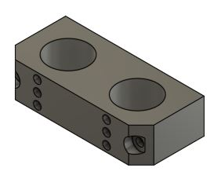
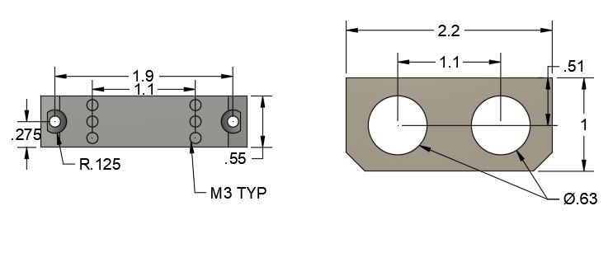

Also See:
WorkHorse Dimensions
Hotend Mount WorkHorse

WorkHorse Files
config.g
Homeall.g
homex.g
Homey.g
Homez.g

Duet 3 Mainboard Setup
Duet3D YAT Commands
Reverse Motor Direction

Duet Wifi
Duet Wifi Setup
Duet 3 Mainboard 6HC
Duet 3 Mainboard Wiring Guide
Duet 3 Mainboard Dual Z-Axis
Duet 3 Troubleshooting Errors
Reprap Firmware

